



2025-2026

[](https://www.bing.com/images/search?q=science+clipart&id=B4E71B5731D40C9941F532831E9CA14968E596F9&FORM=IQFRBA)**Science Fair Information**[](https://www.bing.com/images/search?q=science+clipart&id=B4E71B5731D40C9941F532831E9CA14968E596F9&FORM=IQFRBA)

**Dear Parents/Guardians,**

All Richmond County 3rd–5th grade students are **required** to complete a Science Fair project. Warren Road’s Science Fair will be held **December 2025**, and **projects must be submitted by the morning of November 14** to be eligible for judging.

**What Your Child Needs:**

* **Composition journal** (logbook)
* **3-prong or clear folder** for the typed formal report
* **Tri-fold display board**

This packet is a **guide** to help you and your child through the project. It includes how to:

* Choose a topic and form a testable question
* Conduct research and write a bibliography
* Create a hypothesis and identify variables
* Collect and analyze data
* Set up the display board and write the final report

Please note:

* Projects must be **experiments**, not models (e.g., no volcanoes)
* **No photos of body parts**, including hands, on the display board
* **No experiments involving vertebrate animals, humans (including taste tests), or mold**—these are not eligible for judging

All work should be recorded in the **logbook**, which will be checked on the due dates listed in the packet. These checkpoints count toward your child’s **homework conduct grade**.

Please encourage your child to take responsibility for their project. You may assist with proofreading and typing, but the work should reflect your child’s effort.

Keep this packet in a safe place—**no replacements will be given**. If lost, you may use online resources for guidance.

If you have any questions, please don’t hesitate to contact your student’s science teacher.

[](https://www.bing.com/images/search?q=science+clipart&id=B4E71B5731D40C9941F532831E9CA14968E596F9&FORM=IQFRBA)**Science Fair Due Date Checklist**[](https://www.bing.com/images/search?q=science+clipart&id=B4E71B5731D40C9941F532831E9CA14968E596F9&FORM=IQFRBA)

**Scientist’s Name_____________________Class___________Proj. #_______**

**Title of Project____________________________________________**

|  |  |  |  |  |
| --- | --- | --- | --- | --- |
| Due Date | Assignment | Correct | Needs Improvement | Areas in need of improvement |
| **August 8th, 2024 (or before) all Science Fair packets sent home or posted online for all**  **3rd - 5th graders for parents to review with their students.** | | | | |
| Aug. 22nd, 2025 | Purpose: Topic & Question |  |  |  |
| Sept. 5th, 2025 | Hypothesis, Variables, & Materials List |  |  |  |
| Sept. 12th, 2025 | Procedures/Steps |  |  |  |
| Sept. 19th, 2025 | Reference List  (Must have 3) |  |  |  |
| Sept 20th – Oct. 16th | Science Experiment Work Period |  |  |  |
| Oct. 17th, 2025 | Data, Analysis  (Graphs, Tables, and/or Charts) |  |  |  |
| Oct. 30th, 2025 | Abstract and Formal Reports |  |  |  |
| Nov. 14th, 2025 | Any Revision/Final Project DUE |  |  |  |
| Nov. 21st, 2025 | Turn in classroom winners to grade levels Science Fair representative. |  |  |  |

Science Project Ideas

The following websites are extremely helpful in finding Science Fair project ideas.

This is the best site to use:

<http://www.sciencebuddies.org>

Other resources:

<http://scienceprojects.com>

<http://rosearts.org/naples/ideas.htm>

<http://tetrimore.com>

<http://www.all-science-fair-projects.com>

<http://www.factmonster.com>

**1. Purpose – Ask a Testable Question**

**A testable question is one you can answer by doing an experiment.**

**It has two parts:**

* Part 1: The part that is being tested. This is called the independent variable. This is the part of the experiment you change.
* Part 2: What you observed or measured. This is called the dependent variable.

**Your question should show how one thing affects another:**

* Example Question:  
  *How does the amount of sunlight affect how tall a plant grows?*  
  (You change the sunlight, and you measure the plant’s height.)
* Another Way to Ask:  
  *What is the effect of water temperature on how fast ice melts?*  
  (You change the water temperature, and you measure the melting time.)

✅ Remember: You must be able to measure the result (the dependent variable).

**2. Conduct Your Research and Create a Bibliography**

Note: This information does NOT go on your display board.

Once you’ve chosen your topic, it’s important to learn more about it by reading books, articles, and websites. This will help you better understand your experiment.

**✅ Research Steps:**

1. Read books and articles about your topic. Make sure they are not older than 5–10 years.
2. Use at least 3 sources. Write the source information (citation) above your notes.
3. Take notes in your logbook only. You’ll use these notes later to write your research paper for the formal report.

**📝 How to Write a Bibliography**

Make a list of all the sources you used: books, websites, magazines, interviews, etc. Use the correct format for each type:

**📖 Books:**

**Format:**

*Author’s last name, first name. Book title. City of publication: Publisher, year.*

**Example:**Allen, Thomas B. *Vanishing Wildlife of North America.* Washington, D.C.: National Geographic Society, 1974.

**🌐 Websites:**

**Format:***Author’s last name, first name (if available). “Title of article.” Website name. Date published. Date you visited the site.*

**Example:**Devitt, Terry. “Lightning Injures Four at Music Festival.” *The Why? Files.* 2 Aug. 2001. 23 Jan. 2002. http://whyfiles.org/137/lightning/index.html

**📚 Encyclopedias & Dictionaries:**

**Format:***Author’s last name, first name. “Title of Article.” Encyclopedia or Dictionary Name. Year.*

**Examples:**Pettingill, Olin Sewall, Jr. “Falcon and Falconry.” *World Book Encyclopedia.* 1980.  
“Azimuthal Equidistant Projection.” *Merriam-Webster’s Collegiate Dictionary.* 10th ed. 1993.

[](https://www.bing.com/images/search?q=science+clipart&id=B4E71B5731D40C9941F532831E9CA14968E596F9&FORM=IQFRBA)**3. Construct a Hypothesis**[](https://www.bing.com/images/search?q=science+clipart&id=B4E71B5731D40C9941F532831E9CA14968E596F9&FORM=IQFRBA)

**What’s a Hypothesis?**

A hypothesis is your best guess about what will happen in an experiment, based on what you already know.

**How to Write One:**

Use this sentence stem:

If *(something changes)*, then *(this will happen)*, because *(why you think that)*.

**Example:**

If seeds are frozen before planting, then they will grow faster, because some seeds sprout better after being cold.

[](https://www.bing.com/images/search?q=science+clipart&id=B4E71B5731D40C9941F532831E9CA14968E596F9&FORM=IQFRBA)**Identify the Variables**[](https://www.bing.com/images/search?q=science+clipart&id=B4E71B5731D40C9941F532831E9CA14968E596F9&FORM=IQFRBA)

**Types of Variables in an Experiment**

When you do an experiment, you’ll work with three kinds of variables:

* Independent Variable – This is what *you change* on purpose.
* Dependent Variable – This is what *you measure* or observe.
* Control Variables – These are the things you *keep the same* to make it a fair test.

**Example:**

Let’s say you’re testing how temperature affects seed growth:

* Independent Variable: temperature of where the seeds are stored
* Dependent Variable: number of seeds that grow (germinate)
* Control Variables: number of seeds, how long they’re stored, how much water and sunlight they get

[](https://www.bing.com/images/search?q=science+clipart&id=B4E71B5731D40C9941F532831E9CA14968E596F9&FORM=IQFRBA)**Materials** [](https://www.bing.com/images/search?q=science+clipart&id=B4E71B5731D40C9941F532831E9CA14968E596F9&FORM=IQFRBA)

**Make a list of all materials that you use.**

Make sure to gather everything before you start your experiment!

Example:

* Zip-Loc bags (about 17 cm x 15 cm)
* 60 dry butter beans (not cooked!)
* 3 large paper towels (about 28 cm x 26 cm)
* A permanent marker
* Water that doesn’t have chlorine (or let tap water sit out overnight)
* A room that’s around 70°F (room temperature)
* A refrigerator that’s around 38°F (cold)
* A freezer that’s around 0°F (really cold!)

[](https://www.bing.com/images/search?q=science+clipart&id=B4E71B5731D40C9941F532831E9CA14968E596F9&FORM=IQFRBA)**Procedure** [](https://www.bing.com/images/search?q=science+clipart&id=B4E71B5731D40C9941F532831E9CA14968E596F9&FORM=IQFRBA)

**Write step-by-step directions to explain how to do your experiment. Make sure to use complete sentences and correct punctuation.**

**Example:**

1. **Label** each bag:
   * Room Temp Bean (Control)
   * 50°F Bean (Fridge)
   * 30°F Bean (Freezer)
2. **Fold** paper towels to fit inside the bags. Put one in each.
3. **Add** 20 dry butter beans to each bag.
4. **Place** each bag in the correct spot (room, fridge, or freezer).
5. **Wait** 5 days without moving the bags.
6. **After 5 days**, take them out. Add 15 mL of water to each towel (just enough to make it damp). Leave the beans and towel in the bag.
7. **Put** all bags in a warm, sunny place.
8. **Check** every day for 10 days. Keep towels moist.
9. **Record** what you see. Repeat if needed.

[](https://www.bing.com/images/search?q=science+clipart&id=B4E71B5731D40C9941F532831E9CA14968E596F9&FORM=IQFRBA)**4. Collect Data** [](https://www.bing.com/images/search?q=science+clipart&id=B4E71B5731D40C9941F532831E9CA14968E596F9&FORM=IQFRBA)

**You will need to construct a table to collect your data. A table contains rows and columns.**

* Give your data table a title. The title should contain your independent variable (the one that changes) and the dependent variable (the responding) and be at the top of your table. **For example: *Germination Rate of Butterbean Seeds vs. Temperature***
* Make a row for each independent variable you are testing.
* Make a column for each dependent variable you are measuring.
* Include unit names for each measurement.
* Add an “Average” column or a “Total” column if applicable.

**Example:**

***Germination Rate of Butterbean Seeds vs. Temperature***

|  |  |  |  |
| --- | --- | --- | --- |
| **Days** | **Control – Room Temperature** | **Freezer** | **Refrigerator** |
| **1** | 0 | 0 | 0 |
| **2** | 2 | 0 | 1 |
| **3** | 6 | 2 | 4 |
| **4** |  |  |  |
| **5** |  |  |  |
| **6** |  |  |  |
| **7** |  |  |  |
| **8** |  |  |  |
| **9** |  |  |  |
| **10** |  |  |  |

**\*Keep recording daily for ten days.**

[](https://www.bing.com/images/search?q=science+clipart&id=B4E71B5731D40C9941F532831E9CA14968E596F9&FORM=IQFRBA)**Analysis** [](https://www.bing.com/images/search?q=science+clipart&id=B4E71B5731D40C9941F532831E9CA14968E596F9&FORM=IQFRBA)

**Create a graph of your recorded information. You may use a bar graph or a line graph. If you are showing information that happens over a period of time, a line graph is preferred.**

**Example:**

**You would need to conduct at least three trials. If after the three trials, you have the same results, then you can draw a conclusion.**

[](https://www.bing.com/images/search?q=science+clipart&id=B4E71B5731D40C9941F532831E9CA14968E596F9&FORM=IQFRBA)**Conclusion** [](https://www.bing.com/images/search?q=science+clipart&id=B4E71B5731D40C9941F532831E9CA14968E596F9&FORM=IQFRBA)

**A Scientific Conclusion has these parts in order:**

* **State the prediction.**
* **Include evidence from your data collection. Do not include all your data. Include a high and low, if possible – include averages, or appropriate central measures.**
* **Include a statement that analyzes the data.**
* **Include a statement that tells if the prediction was correct or incorrect. Use the sentence starter: Therefore my prediction was….(correct or incorrect).**

**Example:**

The results of my experiment show that my hypothesis was incorrect. The seeds in the freezer germinated the fewest, while the ones at room temperature germinated the largest number of seeds.

[](https://www.bing.com/images/search?q=science+clipart&id=B4E71B5731D40C9941F532831E9CA14968E596F9&FORM=IQFRBA)**Extension Statement**[](https://www.bing.com/images/search?q=science+clipart&id=B4E71B5731D40C9941F532831E9CA14968E596F9&FORM=IQFRBA)

**In this section, you will tell what you would do differently next time to see if you get the same results.**

**Example:**

I believe that further testing needs to be done to see which temperature induces the highest germination rate. If I was to perform this experiment again, I would use a different type of bean to see if my results would be the same.

[](https://www.bing.com/images/search?q=science+clipart&id=B4E71B5731D40C9941F532831E9CA14968E596F9&FORM=IQFRBA)**Abstract**[](https://www.bing.com/images/search?q=science+clipart&id=B4E71B5731D40C9941F532831E9CA14968E596F9&FORM=IQFRBA)

**The Abstract is a summary of the entire project. It should be typed in three paragraphs using the same font and type size as your Formal Report. Do not punch holes in the Abstract. It is sheet that you will turn in separately from the Formal Report. You do not have to write the Abstract in your notebook. It should be no more than 250 words. Please make sure to do a word count to make sure that you do not go over this number.**

**Paragraph #1: Purpose of the experiment and the Hypothesis**

**Paragraph #2: Procedure written in paragraph form**

**Paragraph #3: Results and Conclusion**

**Example:**

The purpose of this project is to determine if temperature will affect the germination rate of butterbean seeds. It is hypothesized that freezing the seeds for a period of time will cause them to produce more seeds at a quicker rate.

A set number of butterbean seeds were placed in plastic bags marked “room temperature”, “freezer”, and “refrigerator”. The bags were placed in the respective areas and left undisturbed for five days. They were all then moistened and placed in a warm, sunny area where they were observed for ten days.

The results showed that the coldest temperature actually harmed the germination rate of the seeds; therefore, my hypothesis was incorrect. To improve this study, I would try different types of seeds to see if my results could be confirmed.

[](https://www.bing.com/images/search?q=science+clipart&id=B4E71B5731D40C9941F532831E9CA14968E596F9&FORM=IQFRBA)**Formal Report**[](https://www.bing.com/images/search?q=science+clipart&id=B4E71B5731D40C9941F532831E9CA14968E596F9&FORM=IQFRBA)

The formal report should be typed using **Times Roman 12 pt. Font only**.  Your **title** may be **16 pt**.  Your formal report should contain the following, most of which will be copied straight out of your logbook:

**Title Page:**  Center your title in the middle of the page and type it in all capital letters.  **Do not put your name on the formal report anywhere.**

**Table of Contents:** Should look like example below:

Table of Contents

Research Question and Purpose………………………………………………………………………………………………………1

Background Research and Bibliography……………………………………………………………………………………………2

Hypothesis

Materials

Variables

Procedure

Results/Analysis

Conclusion

Extension Statement

Acknowledgments

**\*\*Continue numbering each heading.  Each heading should be on a separate page.  All page numbers should be centered at the bottom of each page in the center.  Your Table of Contents will show the page number that the heading where the heading can be found.  Do not number the Table of Contents page.**

Your “Research” will be a paper that you write from the background notes that you took in your log book.  The paper should be **at least ½ page in length.**

The “Acknowledgments” will give thanks to anyone who assisted you with your project.  Ex:  I would like to thank Mr. Tom Smith and my parents for helping me complete my Science Fair Project.

**DO NOT PUNCH HOLES IN YOUR REPORT.  IF YOUR FOLDER REQUIRES THAT HOLES BE PUNCHED, I WILL DO IT FOR YOU.** **THE ABSTRACT IS NOT PART OF THE FORMAL REPORT.  DO NOT LIST IT IN THE TABLE OF CONTENTS.**

[](https://www.bing.com/images/search?q=science+clipart&id=B4E71B5731D40C9941F532831E9CA14968E596F9&FORM=IQFRBA)**Example Title Page Formal Report**[](https://www.bing.com/images/search?q=science+clipart&id=B4E71B5731D40C9941F532831E9CA14968E596F9&FORM=IQFRBA)

**PAIN, PAIN, GO AWAY!**

**January 25, 2024**

**Warren Road Elementary School**

**5th Grade**

[](https://www.bing.com/images/search?q=science+clipart&id=B4E71B5731D40C9941F532831E9CA14968E596F9&FORM=IQFRBA)**Display Board**[](https://www.bing.com/images/search?q=science+clipart&id=B4E71B5731D40C9941F532831E9CA14968E596F9&FORM=IQFRBA)

**Do’s**

* Do use computer generated graphs and charts.
* Do make display colorful, but limit the number of colors you use.
* Type information for the board.
* Do use headers in the correct order.
* Do use rubber cement to make sure that everything is securely attached to the board. Elmer’s Glue causes everything to wrinkle.
* Do space out everything evenly.
* Do use photographs of the procedure, but make sure that no body parts including hands are shown.
* Do use a catchy title. It should **NOT** be the question that is your purpose statement.

**Don’ts**

* Don’t leave large empty spaces on the board.
* Don’t use tape or staples on the board.
* Don’t handwrite information on the board, including headers.
* Don’t make spelling errors.
* Don’t print in color except for headers if you wish. Colored type makes the information very difficult to read.

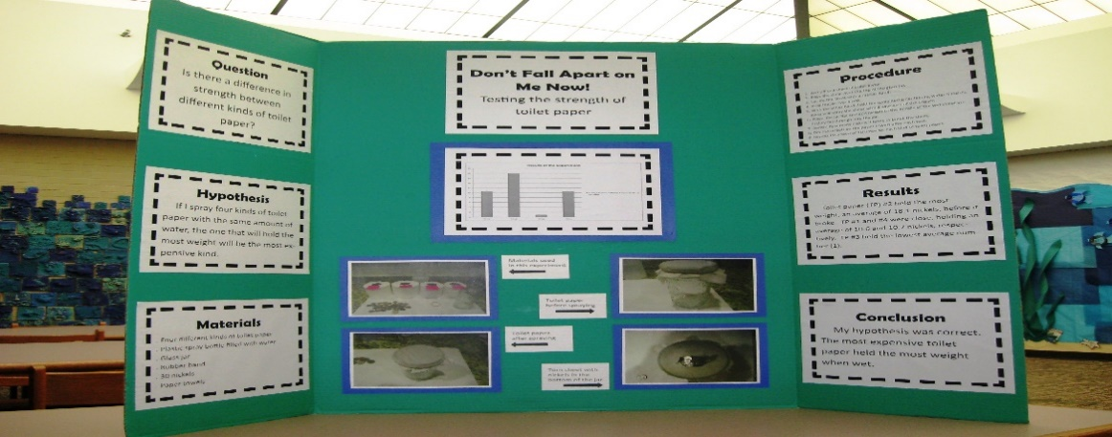

**You should have the following on your board only: Title, Purpose (this is your question), Hypothesis, Materials, Procedure, Results, Conclusion, and any photographs, charts, and graphs.**

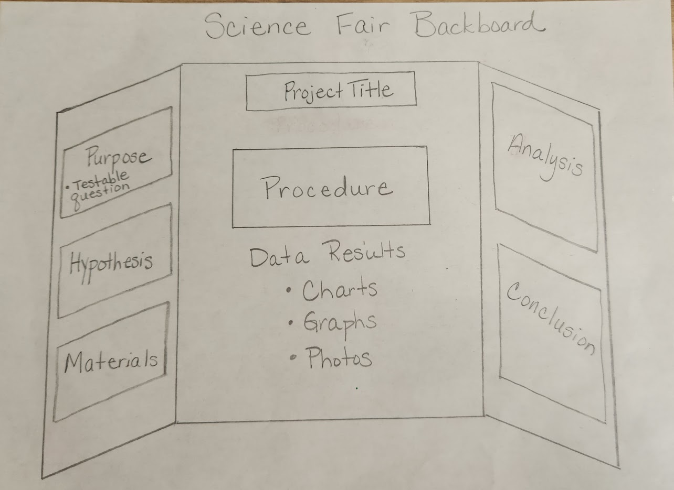

**REMINDER:**

* No names on the project. Use a sticky note or something that can be easily removed.
* DO NOT send the project itself to school. Only turn in the data notebook, formal report, and tri-fold board.
* 3rd Grade DOES NOT need a formal report.